07/11/2025
Hilton Vorster u22510304
Josh Warren u21435091
Trevor Naick u22517554
Deandre Vanmali u21470121
Masana Mashapha u21445045
Luke Brand u22491962
Alyssa Fernandes u22554247
Janco Calitz u21534439
Sibusiso Makhoba u22699032

Expanding a Multilingual Lexicon
for Low-Resource Language Processing
Assignment 3
Contents
Table Of Figures 3
Table Of Tables 3
1) Introduction 4
2) Background 5
2.1) AfriBERTa 5
2.2) AfroXLMR 5
2.3) Explainable Artificial Intelligence (XAI) 5
3) Literature Review 6
3.1) Corpus-Based Extraction 6
3.2) Cross-lingual Mapping 6
3.3) Retrieval-Augmented Generation (RAG) 7
3.4) Integration Effects on Coverage and Accuracy of Sentiment Analysis 7
4) Proposed Approach 9
4.1 Lexicon Expansion 9
4.2) Text Normalization on Lexicon 11
4.3) Corpus-Based Enrichment 13
5) Results 15
5.1) AfriBERTa 15
5.2) AfroXLMR 17
5.3) Statistical Extraction for corpus enrichment 22
5.4) Statistical Extraction for corpus enrichment 23
5.4.1) Frequency analysis using PMI 23
5.4.2) Co-occurrence analysis 24
6) Discussion 25
6.1) Integration Effects on Coverage and Accuracy of Sentiment Analysis 25
6.2) How effective AfroXLMR and AfriBERTa are for aspect-based sentiment analysis with the expanded lexicon 26
6.3) How does ensemble learning of AfroXLMR and AfriBERTa influence sentiment classification performance? 28
7) Limitations 28
7.1) Corpus-Based Enrichment 29
8) Future Directions 30
References 31

Table Of Figures
Figure 1: Lexicon Expansion Flowchart 9
Figure 2: Corpus Based Enrichment 13
Figure 3: LIME Bar Chart 15
Figure 4: LIME Word Cloud 15
Figure 5: Sentiment Distribution Chart 16
Figure 6: Token Alignment AfriBERTa 16
Figure 7: Token Alignment AfriBERTa Individual Connection 17
Figure 8: Token-level Attention 17
Figure 9: Token Spotlight Rings 18
Figure 10: Attention Share Pie Chart 19
Figure 11: BERTViz Layer Attention Map 19
Figure 12: Word Cloud AfroXLMR 20
Figure 13: Sentiment Predication AfroXLMR 21
Figure 14: Classification Report 22
Figure 15: Sentence Classification Results 23
Figure 16: Sentence Classification Results 23
Figure 17: AfroXLMR model training results 27
Figure 18: AfriBERTa model training results 27

Table Of Tables
Table 1 Summary of Missing Values in Expanded Lexicon 11
Table 2 Summary of Auto-Corrections 12
Table 3: Statistical Extraction Enhanced with Co-occurrence 24

1) Introduction
The world is shifting to strongly depending on intelligent machines as norm in society (Dwivedi, Dave et al. 2023). Multiple different concepts and technologies have been developed to have society perform more efficiently (i.e. Driverless cars, flexible email filters, etc) (Dwivedi, Dave et al. 2023). The implementation of these ideas and innovations stem from the widely adoption of machine learning (ML)-based system that has been developed and employed across several different domains to support human users (Dwivedi, Dave et al. 2023). Explainable artificial intelligence (XAI) strives to provide a clear and understandable explanation about the inner workings of ML models as well as provide useful information for outcomes that users can use to draw conclusions (Dwivedi, Dave et al. 2023). The incorporation of XAI provides a significant benefit but the underlying algorithm needs to be understandable to allow users to grasp a complete understanding of the system decides as it can affect critical sectors (i.e. healthcare, finance, etc.) and have extremely dreadful consequences(Dwivedi, Dave et al. 2023).
The world is an extremely diverse society with multiple languages that led to a communication barrier between different audiences (Lawless and Civille 2013). This challenge has led to the development of lexicons as a standardized vocabularies that can be used to aid in communicating among diverse groups (Lawless and Civille 2013). This standardization of sensory vocabulary across multiple parties helps facilitating communication (Lawless and Civille 2013). The assignment uses a sentiment lexicon to help describe the polarity of a textual context (Sadia, Khan et al. 2018). It provides a better explanation and understanding for users and easily implemented compared to ML based algorithms (Sadia, Khan et al. 2018). However, the challenges are the large amount of involvement human beings need to contribute to process analysation of the text (Sadia, Khan et al. 2018). The assignment is faced with challenges as languages are considering low-resource languages (LRLs) as it can be considered less studied, resource scarce, less computerized, less privileged, less commonly taught or low density compared to other lexicons (Magueresse, Carles et al. 2020).
The report is structured as follows: section 2 provides the background about AfriBERTa, AfroLMXR and explainable artificial intelligence, section 3 provides the literature review, section 4 the proposed approach for the assignment, section 5 is the results generated from the code aspect, section 6 is the discussion of the lexicon and different language models, section 7 is the limitation of the models and finally section 8 which can highlight future direction to resolve issues around low-resource lexicon models.

2) Background

2.1) AfriBERTa
AfriBERTa is a language model that was based on the XKM-RoBERTa language model. AfriBERTa was trained on one gigabyte of text-based data from a total of 11 African languages The AfroBERTa performed significantly and perform better than other based language model such as mBERT and XLM-RoBERTa on different tasks. (Raychawdhary, Bhattacharya et al. 2025) AfriBERTa is fine-tuned version of RoBERTa to account for African languages and has demonstrated performance levels that can handle different task such as text classification and named entity recognition. This performance was for multiple African Languages and including languages that the model was not pre-train on (Gokani 2023).

2.2) AfroXLMR
AfroXLMR is a language model that was based on the XKM-RoBERTa language model. AfroXLMR has indicate significantly that it can outperform competitive existing model as well as improve upon the zero-shot classification for unseen languages. AfroXLEM was trained on seventeen African languages which included complex high resource languages (i.e. Arabic, French and English) (Raychawdhary, Bhattacharya et al. 2025). AfroXLMR is a multilingual adaptive fine-tuning technique that can adapt to multiple languages and can maintain downstream performance in both low and high resources languages as it is pre-trained on a combination of both African and non-African language. This combination allows for a more improved and adaptive multilingual transfer learning (Gokani 2023).

2.3) Explainable Artificial Intelligence (XAI)
Explainable Artificial Intelligence is a collection of machine learning (ML) techniques to help aid humans in producing more explainable models that users can grasp a clear explanation and trust when using explainable models (Dwivedi, Dave et al. 2023). XAI can be broken down into two different phases, Understanding Phase and Explaining Phase, that different stake holders (i.e. Customer, User, businesses, etc.) can use to help produce meaningful results to aid decision making (Dwivedi, Dave et al. 2023). The development of ML algorithm has led to a downside called “Black Box” nature as the complexity of these algorithms cause users to distrust ML models and hesitate to use these models (Machlev, Heistrene et al. 2022). Therefore, the main responsibility of XAI is to provide different stakeholders a great explanation of the results ML models produces (Machlev, Heistrene et al. 2022).

3) Literature Review
The expansion of multilingual sentiment lexicons to include low-resource languages, in this case, specifically African linguistic contexts, has become increasingly important in Natural Language Processing (NLP). Many African languages are underrepresented and have limited integration into computational tools, as traditional sentiment analysis systems are mainly optimized for high-resource languages, such as French and English. Multilingual lexicon expansion is possible with corpus-based extraction, cross-lingual mapping and RAG, which ultimately leads to richer sentiment refinement in low resource languages. A foundation for this multilingual expansion is possible through the use of LLMs and XAI (Malinga et al., 2024).

3.1) Corpus-Based Extraction
Corpus-based extraction is used to identify and extract words and phrases that are sentiment bearing, from the large text corpora in low-resource languages. This extraction type relies on annotated or unannotated text data in order to identify sentiment words. This is done through the use of machine learning, or statistical techniques. The corpora of low-resource languages should be augmented with related languages, or multimodal data, due to data scarcity challenges when working with low-resource languages (Chen, Shang et al. 2025). Pointwise Mutual Information (PMI), as well as frequency analysis, can be seen as the most effective tools for identifying sentiment co-occurrences within a textual dataset. This ensures that the lexicon expansion would stay grounded.

3.2) Cross-lingual Mapping
Cross-lingual mapping is used to transfer sentiment knowledge from high-resource languages, such as English, to low-resource languages, such as Xhosa or Afrikaans. This is made possible due to cross-lingual mapping employing bilingual lexicons, embeddings and, or transformations. Techniques used for cross-lingual mapping include bilingual dictionary induction, as well as linear word embedding projections. Only a couple thousand word pairs are used to align sentiment dimensions across different languages (Abdalla and Hirst 2017). By leveraging these word pairs, the coverage of sentiment dimensions can be extended to low-resource languages, such as Xhosa, Afrikaans or even Zulu. These techniques improve the coverage in low-resource language contexts, as it allows sentiment lexicons to be mapped without full translations, which in turn, maintains sentiment equivalence (Klimczak, Fryczak et al. 2024).

3.3) Retrieval-Augmented Generation (RAG)
Retrieval-Augmented Generation (RAG) is able to produce enriched outputs through the retrieval of relevant knowledge integrated with generative models. RAG has the ability to retrieve both linguistic and sentiment details from multilingual corpora, or databases. It is then able to generate new sentiment entries that are adapted for the target language resource, as a part of sentiment lexicon expansion (Li, Luo et al. 2024). The RAG approach helps to minimize vocabulary gaps and improves the overall richness of the lexicon, by combining RAG with LLMs.

3.4) Integration Effects on Coverage and Accuracy of Sentiment Analysis
Through the integration of low-resource languages into the lexicon, the coverage and accuracy of the sentiment analysis is impacted. In a study done by Chen and Skiena (2014), they built sentiment lexicons for 136 different languages, where they achieved a 95.7% polarity agreement with already established lexicons, as well as an overall coverage of 45.2%. In a similar study by Koto et al. (2024), the researchers were able to extend the NRC-VAD lexicon, by adding 20000 low-resource lexemes. The added lexemes were from 15 low-resource languages and ultimately expanded the lexicon to over 2 million entries. Therefore, based on these findings, it is clear that by adding low-resource lexemes, the lexicon’s coverage can be expanded.
In terms of accuracy, Mabokela et al. (2025) conducted a study of Southern African languages, specifically focusing on Nguni and Sotho-Tswana languages. Based on these pre-trained models, it achieved weighted F1 scores of above 77% for Nguni languages and above 63% for Sotho-Tswana languages. This demonstrates the feasibility of sentiment modelling in the context of Southern African languages. Gao et al. (2015) observed that bilingual word graph propagation improved the recall and precision regarding the sentiment lexicon learning. Recall improved from 0.623 to 0.708 and the precision values ranged between 0.72 to 0.97 across the different language pairs.
Through the integration of low-resource languages into sentiment lexicons, both the coverage and accuracy can be improved. The only challenges that arose was in cases where extremely low-resource languages achieved lexicons of less than a 100 words. This could have been due to source materials that were limited. Domain specific variations and word sense ambiguity do remain challenging due to it requiring careful strategies with regards to filtering.
Therefore, multilingual sentiment lexicon can be expanded to include low-resource languages by integrating the use of corpus-based extraction, cross-lingual mapping and RAG. Corpus-based extraction, cross-lingual mapping, as well as RAG, can be combined into a unified framework for multilingual lexicon development. Corpus-based extraction techniques can identify and extract sentiment terms. Cross-lingual mapping allows that the extracted candidates can be aligned with the high-resource language sentiment features. The extracted candidates are also validated. Thereafter, RAG can be implemented to refine, expand and contextualize the lexicon entries, through the generation capabilities of RAG (Li, Luo et al. 2024, Chen, Shang et al. 2025). Together, these methods can be used to create a scalable pipeline for multilingual lexicon development in low-resource languages, specifically focusing on languages spoken in Africa.

4) Proposed Approach

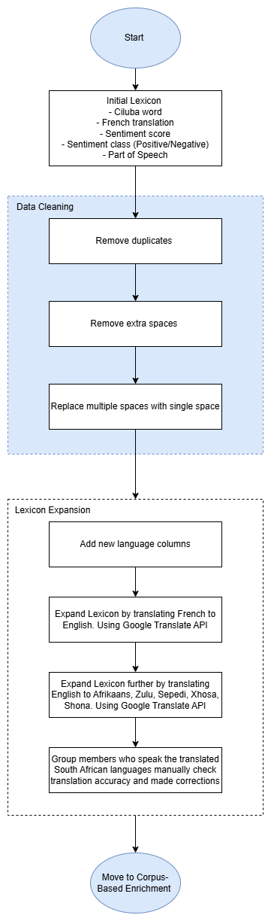
4.1 Lexicon Expansion

Figure 1: Lexicon Expansion Flowchart

Figure 1 depicts the process for expanding the lexicon into a multilingual lexicon with sentiment scores for the various language. This expansion framework combines preprocessing steps, LLM-assisted translations (via Google Translate API), and manual correction by native speakers to ensure consistency across languages.
The original lexicon dataset contained 6963 records of Ciluba and French words with an associated sentiment score, sentiment class which ranged from -9 (negative) and +9 (positive), and the part of speech (e.g. verb, noun, adjective). Before translating any of the French words to English the dataset was cleaned to ensure there were no errors s carried down into the translation process. Data cleaning steps included checking for exact duplicates in the data, it was found that there were 317 duplicates in the date and after removing them the dataset contained 6646 unique records. Also to ensure consistent formatting before translation all text columns were stripped of leading and trailing spaces, and any occurrences of multiple spaces were replaced with a single space.
Additional columns were then added to the dataset for English, Zulu, Afrikaans, Sepedi, Xhosa, Shona translations. The Deep Translator library, which uses Google Translate API, was used to automatically translate French words across the other languages. Although Google Translate provides a wide range of multilingual capabilities and is easy to use, a study was done to evaluate the effectiveness of using it as AI-powered translation tool and found that struggles to handle complex content in low-resource languages (Majj, Am palam, Raju, 2025). To mitigate this,the translation process followed a two-step pipeline. First, the French words were translated to English this helps to ensure a reliable base translation since English is widely understood and supported. Then the English words were used as a base to translate into the South African languages. The South African translations were then checked by group members manually to identify and fix any errors in the translations, resulting in an accurately expanded lexicon.
Through further inspection a small number of missing translations occurred due to the API or text errors that weren’t noticed. Some reasons as to why the API may have failed could be: these words didn’t have a direct translation in the target language, special characters or API rate limits. It is typical for these errors to occur because according to a study done by Agrawal, Fazili and Jyothi (2024), it was found that machine translation errors disproportionality affects low-resource languages, resulting in significant variations in accuracy and consistency across languages. Table 1 summarizes the number of missing translations per language, showing that the overall translation completeness was high, with only a few missing translations across the South African languages.
Table 1 Summary of Missing Values in Expanded Lexicon
Language | Missing
Zulu | 1
Afrikaans | 0
Sepedi | 0
Xhosa | 1
Shona | 1

4.2) Text Normalization on Lexicon
After the lexicon expansion, a normalisation and tokenisation pipeline was applied to the output of the lexicon expansion process, insuring consistency and reliability across all languages. This is an extremely important process in NLP because inconsistency in the casing, punctuation and spelling can introduce noise later during the sentiment modelling. The normalisation process followed a multistage process combing automated and human-guided corrections:
Lowercasing: All words in the dataset across all language columns were converted to lowercase using the .lower() function. This standardises the data and helps reduce the risk of case-related duplication.
Spelling Corrections: This followed a hybrid strategy. Firstly, an automated spell-checker was done using the PySpellChecker library for English. Then using RapidFuzz to do fuzzy matching which calculates a ‘similarity score’ between two strings. The score shows how much one string needs to be changes to become identical to another (Pykes, 2025). This was done on the non-English languages, it compared each token against its respective language vocabulary and selected candidates with a similarity score greater than 90. Manual review queue, all tokens with low similarity scores were automatically added to the que for human inspection. In total, 10478 tokens were flagged for manual verification. The correction log recorded 11155 total spelling changes, it shows that the languages were relatively balanced during correction across high and low resource languages.

Table 2 Summary of Auto-Corrections
Language | Auto-Corrections
Ciluba | 1905
French | 1974
English | 1428
Zulu | 1188
Afrikaans | 1307
Sepedi | 1087
Xhosa | 1159
Shona | 1107

Punction Removal: Using the String library, the following punctation marks were removed; commas, periods and exclamation marks. This step also helps to reduce noise however, hyphens and apostrophes were kept as they carry linguistic meaning in several of the non-English languages.
Whitespaces and Special Characters: Expressions were used to remove excess whitespaces, tabs, and non-alphanumeric symbols. Accent marks that could distort meaning in African languages were normalised.
For the tokenisation, a whitespace-based tokenizer was used and new columns with lists of tokens were created. The process of tokenising is a fundamental part of NLP that segments the text into smaller units, for example “speak again” is transformed into [speak, again]. This provides lightweight inputs suitable for sentiment analysis. By tokenising the lexicon dataset, it is now prepared for statistical lexicon-based methods like PMI and modern transformer-based approaches.

4.3) Corpus-Based Enrichment
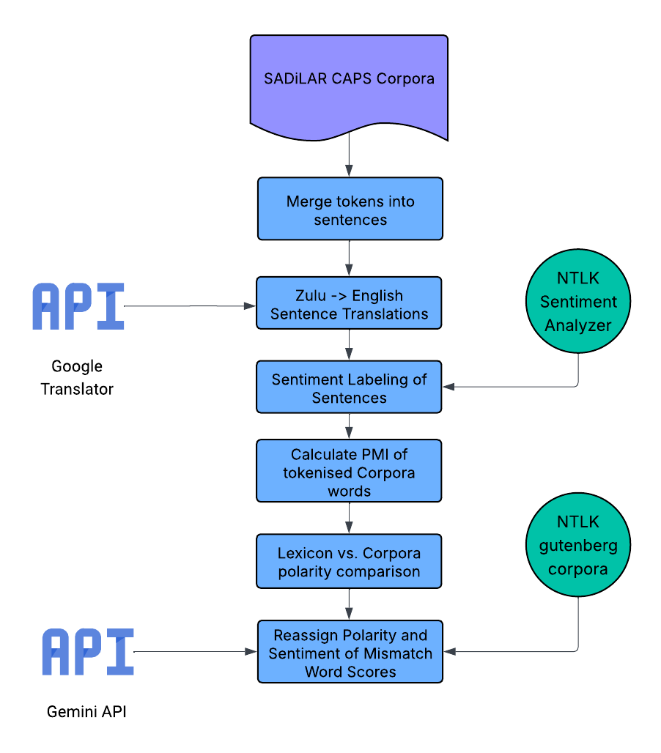
Figure 2: Corpus Based Enrichment
The approach used to address the corpus-based enrichment process is depicted in Figure 2. This approach was developed to ensure that the semantic distance between a word and its sentiment seed words can be used as a metric to determine sentiment polarity for the targeted word (Darwich, Mohd Noah et al. 2019). The approach begins sourcing an existing corpus from the resource catalogue from the Department of Science, Technology and Innovation. The corpus sourced was readily in a lemmatised state, part of speech (POS) tagged and morphologically analysed. The corpus texts are all in the isiZulu, the aim is to train the lexicon on low-resource languages therefore the corpus was selected to match that criteria.
The existing corpus was pre-tokenised with punctuation and sentence line tagging. This further built on the approach in Figure 2, “Merge tokens into sentences”. The individual tokens were combined into single sentences and were cleaned to exclude punctuation marks and sentence line tagging. This was then followed by a series of translations made to the individual sentences to English. The isiZulu texts were translated to English using Google Translator to support the SentimentAnalyzer API from NTLK. This provided the sentences with sentiment to calculate polarity. Once polarity scores are calculated, the resulting polarity score will determine the known sentiment label for the targeted word serving as the basis for enriching the sentiment within the lexicon, by assigning or revising polarity labels (Rice and Zorn 2021).
To ensure the data within the lexicon is further enriched, we conduct a lexicon to corpus comparison, searching for matching sentiments and polarities. This step in the approach is crucial as it detects words that might be classified out of context and bare hallucinated sentiments. Therefore, this step essentially identifies the words that have a sentiment in the lexicon that is either consistent or inconsistent with the real usage in the corpus and flags them for enrichment (Rice and Zorn 2021).
The approach towards enriching the sentiments of the lexicon concludes with a Retrieval-Augmented-Generation (RAG) approach. Using Googles Gemini, this step uses AI to address words with polarity mismatches using texts containing that word from the Gutenberg corpus by NTLK and reassigning sentiment values. This step makes use of the Gemini-2.5-Flash to analyze the words current polarity in the lexicon and corpus, uses Vader to set the baseline polarity then finally uses the corpus texts provided to return a refined polarity score.
This approach embodies the best practices outlined in recent literature, emphasizing corpus-driven correction and RAG generation for sentiment analysis (Rice and Zorn 2021). With corpus-based enrichment, we utilize PMI to revise sentiment lexicon polarity based on an authentic corpus before making use of RAG approaches to integrate retrieval of external knowledge to verify or enrich sentiment correction.

5) Results

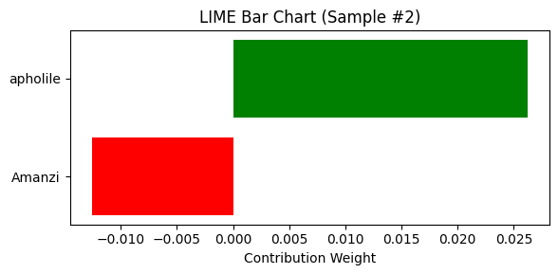
5.1) AfriBERTa
Figure 3: LIME Bar Chart
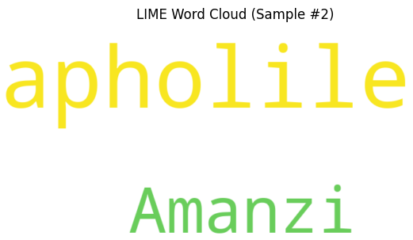
Figure 3 presents the quantified contribution that each word has contributed to the model’s output. The word “apholile” has a positive contribution weight of +0.026 which means the word supports the predicted class. The word “amanzi” has a negative contribution weight of -0.010 meaning that it opposes the predication class. The model was driven mainly by the word “apholile” which outweighed the weaker negative influence of “amanzi”
Figure 4: LIME Word Cloud
Figure 4 presents the visual representation of the words which contributes the most in a text aspect to AfriBERTa’s classification decision. The word “apholile” is the more prominent word displayed in LIME word Cloud as it appears in larger, yellow text compared to “amanzi”. This visualization indicates that “apholile” has the strongest influence on the model’s ability to predict and “amanzi” has a weaker influence. In addition, the yellow and green text colour indicates that the two words contribute positively to the predicated class. Therefore, AfriBERTa identifies that “apholile” is the key indicator for the predicated class.
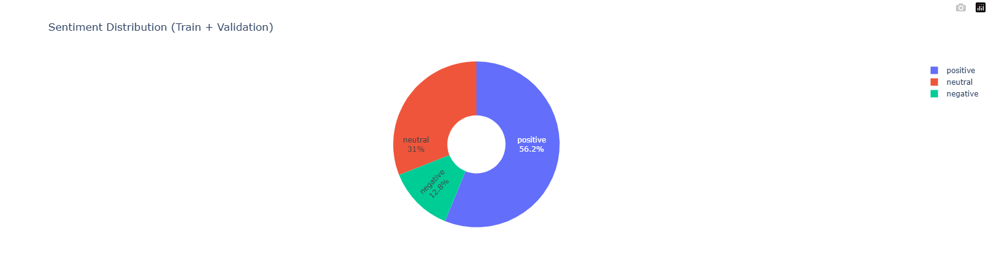
Figure 5: Sentiment Distribution Chart
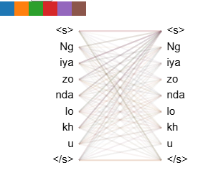
Figure 5 presents the sentiment distribution chart which stats that across training and validation the sets are 56.2% positive, 31% neutral and 12.8% negative. This visualization indicates an imbalance within the dataset as the it is skewed towards the positive sentiment. This imbalance can affect the model performance and mainly struggle when detecting negative sentiment. Therefore, a risk of bias can be present when using AfriBERTa as the model may overpredict positive sentiment as it is the dominant class.
Figure 6: Token Alignment AfriBERTa
Figure 6 presents the token alignment between slightly different sequences as it represents the two sequences of tokens: Ng, iya, xo, nda, lo, kh and u. The lines connected between the left and right sequences are connecting the different tokens, but the alignment is not a perfect one-to-one connection. This is the representation of the cross-sequence alignment of possibly the translation or paraphrase mapping. The lines indicate how AfriBERTa maps semantic or syntactic relationships between tokens.
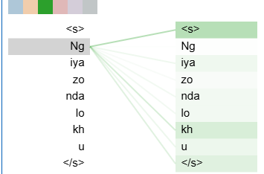
Figure 7 presents the self-alignment of identical sequences as it represents the same sequences on both sides: Ng, iya, xo, nda, lo, kh and u. The lines connected between the left and right sequences are connecting each token to its identical counterpart, and the alignment is a perfect one-to-one connection. AfriBERTa presents a stable token preservation.
Figure 7: Token Alignment AfriBERTa Individual Connection
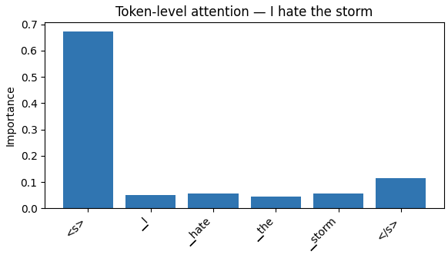
5.2) AfroXLMR
Figure 8: Token-level Attention
The visualisation in figure 8, is a token-level attention for an English sentence “I hate the storm”. The visualisation displays the level of attention that the AfroXLMR model assigned to each token during sentiment prediction. The attention levels are:
- The “hate” token sentiment received the highest weight and meaningful attention. This confirms that the model recognized the sentiment as the main negative contributor.
- The sentiment tokens of “the” and “storm” received lower weights. This accurately reflects their contextual roles played, as well as their sentiment-neutral roles.
The visualisation, therefore, displays that the AfroXLMR is able to accurately determine and emphasize emotionally charged words during inference. The word “hate” drives negative polarity, which aligns with how human-beings reason.
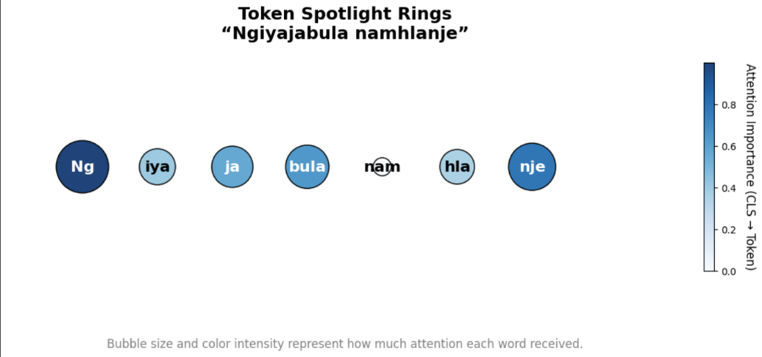
Figure 9 displays a Zulu sentence. The English translation is “I am happy today”. This sentence displays and is analysed using token spotlight rings. The colour and size of the bubble rings represent the attention importance in the sentence. The visualisation is analysed as the following:
Figure 9: Token Spotlight Rings
- The AfroXLMR model assigned the highest attention to the “Ng” and “nje” tokens. This displays that there is a strong focus on the sentence’s temporal and emotional cues.
- The model displays a medium level of attention on the tokens “iya”, “ja”, “bula” and “hla”, which indicates that the model has a partial understanding the Zulu language’s verb morphology.
- The “nam” token receives minimal attention from the model, suggesting that the model deprioritizes locative and/or conjunction elements.
Therefore, the AfroXLMR model is able to capture sentiment cues in morphologically rich African languages, such as Zulu. The token-level awareness displays that multilingual embeddings that are pretrained, is generalized across agglutinative structures.

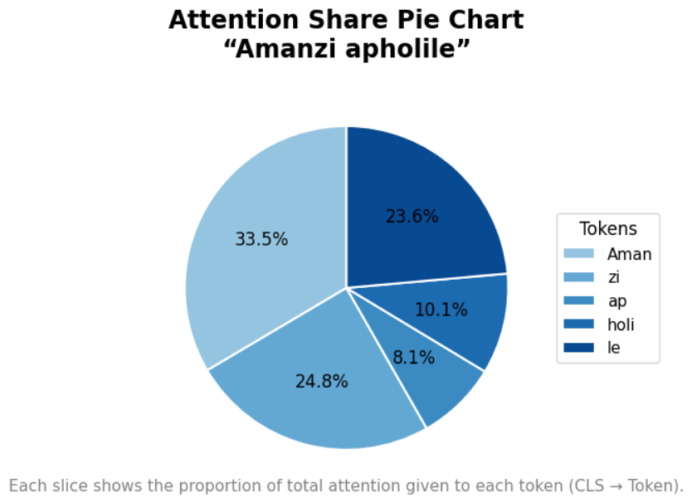
The visualisation in figure 10 displays the attention share of a Xhosa sentence, which translates to “The water is cold” in English. Each slice of the pie chart represents the proportion of attention given to each token. The visualisation is analysed as the following:
Figure 10: Attention Share Pie Chart
- The “Aman” token has the most level of attention with 33.5% and is then followed by “zi” with an attention level of 24.8% and “le” with an attention level of 23.6%.
- The attention levels of “ap” and “holi” receives moderate attention, highlighting that the model is able to recognize negative polarity.
The pie chart displays that there is a balanced attention across sentiment-bearing morphemes. Therefore, AfroXLMR is able to handle sub word segmentation effectively, whilst still being able to retain semantic coherence in low-resource African languages, such as Xhosa, which is a morphologically rich language.
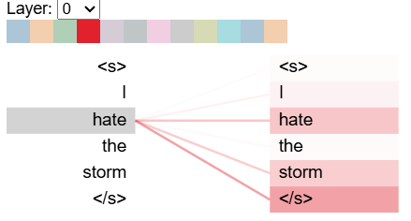
Figure 11: BERTViz Layer Attention Map
Figure 11 displays a BERTViz layer attention map, specificallt focusing on the negative polarity of the English sentence “I hate the storm”. The AfroXLMR model’s internal attention mechanisms are displayed, when processing negative sentiment input. In this visualization, token-to-token connections are displayed, where the deeper red colour indicates stronger attention weights between the tokens. The visualization is analysed as follows:
- The word “hate” has a dominant attention focus, specifically from and towards the classification token. This indicates that the AfroXLMR identifies this word as the primary driver of the negative sentiment, relating to that of Figure 8.
- The “I” and “storm” tokens receive a weaker token attention, which supports the word’s contextual roles.
- The attention in the visualization is symmetrically propagated, indicating that the model is able to understand the relational dependency of “hate” and “storm”, within a negative context.
Therefore, the BERTViz output from the AfroXLMR model indicates that the model is able to isolate sentiment-bearing words effectively during inference. The focus on the word “hate” shows that the focus of the model is aligned with the human semantic interpretation. This provides transparency on how sentiment polarity can be derived within the context of multilingual languages.
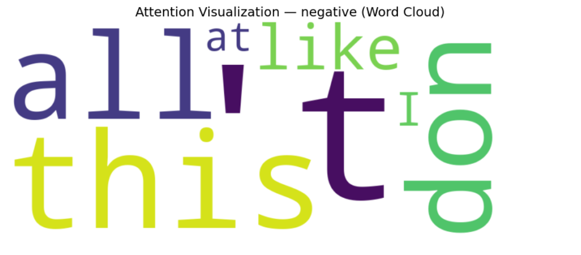
Figure 12: Word Cloud AfroXLMR
A word cloud visualization of the AfroXLMR’s attention scores for words that have negative polarity is displayed in figure 12. The font size relates to the relative attention importance assigned to each of the tokens, across different sentences. The visualization is analysed as follows:
- The larger words of “this”, “all”, “don’t” and “like” indicates that these tokens have higher aggregated attention weights during the model’s inference on negative samples.
- The smaller words of “I” and “at” provides minimal sentiment value contribution but is still contextually acknowledged by the model.
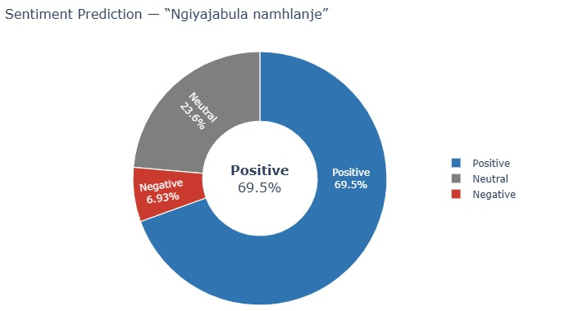
The word cloud in the visualization emphasises the key negative expressions of the AfroXLMR model, which it relies on for polarity detection. Therefore, the model does not only capture lexically explicit negative terms, but also broader contextual indicators in negative polarity. The model’s attention mechanism is therefore able to distribute importance across different sentimentally charged tokens.
Figure 13: Sentiment Predication AfroXLMR
The visualisation in figure 13 displays the sentiment prediction distribution of a Zulu sentence, translating to “I am happy today” in English. The donut chart in the visualisation indicates the AfroXLMR’s confidence across different sentiment categories, namely “Positive”, “Negative” and “Neutral”. This visualisation is analysed as follows:
- Positive: This class dominates the prediction output with a probability of 69.5%. This indicates that the model is able to identify that the sentence is expressing happiness.
- Negative: This class has a very low sentiment of 6.93%. This indicates that the model has got minimal confusion between different emotional polarities.
- Neutral: This class has a sentiment of 23.6%. This indicates that the model has got minimal uncertainty due to the morphological complexity or linguistic nuances of verbs in the Zulu language.
Therefore, the AfroXLMR model is able to successfully capture the positive emotional tone within the context of the Zulu language, even when it has to deal with agglutinative linguistic structures. This validates the model’s multilingual sentiment classification, with being able to align the positive class of the lexical content. The small percentage of the neutral attention class still indicates a bit of contextual uncertainty from the model, which is behaviour found in low-resource language scenarios, where sentiment boundaries can blur.

5.3) Statistical Extraction for corpus enrichment
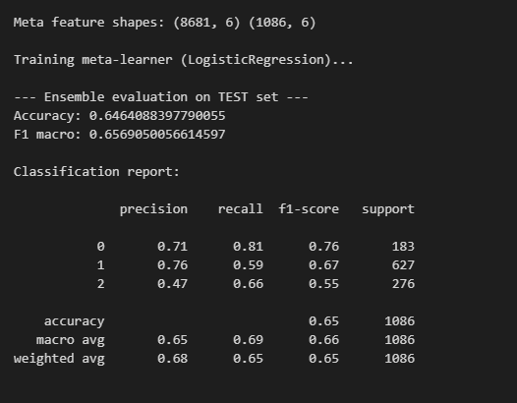
Our group went on to complete ensemble learning and retrieved the results displayed in figure X bellow. These results indicates that if we combine AfroXLMR and AfriBERTa through a stacking approach it positively influences sentiment classification performance. The meta-learner, which we used for our ensemble learning, was trained using Logistic Regression on the combined probability outputs of both models. This led to ensembled model achieving an overall accuracy of 65% and a macro F1-score of 66%, which demonstrates that the new model is stable and can consistent predictive capabilities across all sentiment classes.

Figure 14: Classification Report
We also used LIME visualisations to understand how the stacked model interprets sentiments at the token level. In the first image the sentance, “Ngiyazonda lokhu” was correctly classified as negative (0.94), with the model highlighting “Ngiyazonda” as the dominant negative cue. In contrast the second sentence, “Umlhaba muhle” was classified as positive (0.85), where “muhle” strongly contributed to the positive sentiment. These explainability visuals confirm that the ensemble effectively identifies key sentiment-bearing words within African languages, showing meaningful alignment between predicted probabilities and semantic cues in the text.
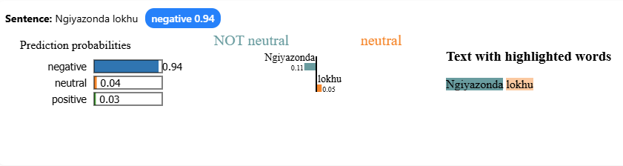
Figure 15: Sentence Classification Results
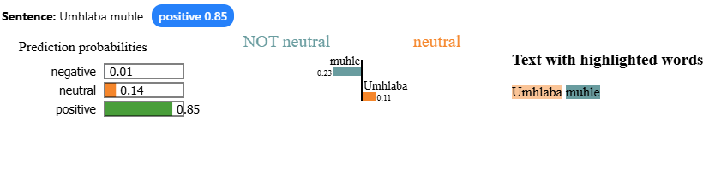
Figure 16: Sentence Classification Results

5.4) Statistical Extraction for corpus enrichment
This section examines the relationship between the words in the corpus and their associated sentiment categories. This was task was achieved through the integration of two processes namely, frequency analysis using PMI and co-occurrence analysis to strengthen and expand sentiment associations.

5.4.1) Frequency analysis using PMI
To start off the process, the corpus dataset was tokenised, cleaned and normalised by removing stop-words and applying lemmatisation. Once the dataset was prepared, the token’s (individual words extracted from the text corpus after preprocessing) frequencies for the individual sentiment categories (negative, positive and neutral) were calculated. Pointwise Mutual Information (PMI) was then computed using the frequency distributions that were calculated in the previous step to measure how strongly PMI aligned with positive and negative contexts. A high, positive PMI (PMI_Pos) indicated that the words had frequently occurred in positive contexts and a high, negative PMI (PMI_Neg) indicated that the words had frequently occurred in negative contexts. The difference in PMI (PMI_Diff), PMI_Pos – PMI_Neg, enabled the ranking of the words based on their sentiment polarity. The result was a sentiment-weighted lexicon where words were sorted according to their tendency toward positive or negative usage, an excerpt of this result is depicted in Table X.

5.4.2) Co-occurrence analysis
Once the frequency analysis was done, co-occurrence was taken a step further. Co-occurrence was not only analysed in terms of tokens that frequently appear when a sentiment is expressed, but also in terms of two words appearing in the same context. This was done to strengthen sentiment assignments. The tokens were extracted from the corpus along with co-occurring words. The frequency distribution was computed across the sentiment categories for the word pair. Relative sentiment ratios were derived to determine the dominant sentiment for each co-occurrence relationship. A log-odds association score was used to capture how strongly a token’s sentiment orientation was supported by its surrounding context.
This analysis allowed words whose sentiment became clearer when considered next to specific neighbouring words to be identified. These strong co-occurrence pairs were then merged back into the PMI lexicon, reinforcing sentiment labels. The final lexicon contains each token and its PMI-based tendency, the co-occurring word and a final sentiment label, depicted collectively with the results obtained from the frequency analysis in Table 3.
Table 3: Statistical Extraction Enhanced with Co-occurrence
Tokens (Zulu) | Co-occur | Negative | Neutral | Positive | Total Freq | Positive Ratio | Negative Ratio | Dominant Sentiment | Association
abadala | bethi | 2 | 1 | 1 | 4 | 0.25 | 0.50 | Neg | -0.999997
abenza | imisebenzi | 1 | 1 | 2 | 4 | 0.50 | 0.25 | Pos | 0.999997
baqinisile | abadala | 2 | 1 | 1 | 4 | 0.25 | 0.50 | Neg | -0.999997
bese | uyinika | 1 | 1 | 2 | 4 | 0.50 | 0.25 | Pos | -0.999997
bhala | incwadi | 1 | 1 | 2 | 4 | 0.50 | 0.25 | Pos | 0.999997
bhala | inombolo | 1 | 1 | 4 | 6 | 0.67 | 0.17 | Pos | 1.999994
chaza | isizathu | 1 | 1 | 4 | 6 | 0.677 | 0.17 | Pos | 1.999994
ekubhebhethekiseni | udweshu | 1 | 1 | 2 | 4 | 0.50 | 0.25 | Pos | 0.999997
ekugqamiseni | indikimba | 1 | 1 | 2 | 4 | 0.50 | 0.25 | Pos | 0.999997

6) Discussion

6.1) Integration Effects on Coverage and Accuracy of Sentiment Analysis
Through the integration of low-resource languages into the lexicon, the coverage and accuracy of the sentiment analysis is impacted. In a study done by Chen and Skiena (2014), they built sentiment lexicons for 136 different languages, where they achieved a 95.7% polarity agreement with already established lexicons, as well as an overall coverage of 45.2%. In a similar study by Koto et al. (2024), the researchers were able to extend the NRC-VAD lexicon, by adding 20000 low-resource lexemes. The added lexemes were from 15 low-resource languages and ultimately expanded the lexicon to over 2 million entries. Therefore, based on these findings, it is clear that by adding low-resource lexemes, the lexicon’s coverage can be expanded.
In terms of accuracy, Mabokela et al. (2025) conducted a study of Southern African languages, specifically focusing on Nguni and Sotho-Tswana languages. Based on these pre-trained models, it achieved weighted F1 scores of above 77% for Nguni languages and above 63% for Sotho-Tswana languages. This demonstrates the feasibility of sentiment modelling in the context of Southern African languages. Gao et al. (2015) observed that bilingual word graph propagation improved the recall and precision regarding the sentiment lexicon learning. Recall improved from 0.623 to 0.708 and the precision values ranged between 0.72 to 0.97 across the different language pairs.
Through the integration of low-resource languages into sentiment lexicons, both the coverage and accuracy can be improved. The only challenges that arose was in cases where extremely low-resource languages achieved lexicons of less than a 100 words. This could have been due to source materials that were limited. Domain specific variations and word sense ambiguity do remain challenging due to it requiring careful strategies with regards to filtering.
Therefore, multilingual sentiment lexicon can be expanded to include low-resource languages by integrating the use of corpus-based extraction, cross-lingual mapping and RAG. Corpus-based extraction, cross-lingual mapping, as well as RAG, can be combined into a unified framework for multilingual lexicon development. Corpus-based extraction techniques can identify and extract sentiment terms. Cross-lingual mapping allows that the extracted candidates can be aligned with the high-resource language sentiment features. The extracted candidates are also validated. Thereafter, RAG can be implemented to refine, expand and contextualize the lexicon entries, through the generation capabilities of RAG (Li, Luo et al. 2024, Chen, Shang et al. 2025). Together, these methods can be used to create a scalable pipeline for multilingual lexicon development in low-resource languages, specifically focusing on languages spoken in Africa.
6.2) How effective AfroXLMR and AfriBERTa are for aspect-based sentiment analysis with the expanded lexicon
The result from this study indicate that AfroXLMR perform extremely well for languages test (i.e. isiXhosa and isiZulu) as it achieved a F1 score that exceeding 80%. The study finds that it performs a total 4% better than other models with a F1 score of 71.03% and this model was the best overall weighted F1 score. The study derived that AfoXLMR performance was most consistent with sentiment analysis which these languages and achieved the highest confidence intervals which can indicate highest stability. In addition, the study reveals that AfriBERTa performed moderately well as it achieved a F1 score around 64% which is considerably impressive as AfriBERTa was not pre-train on any of the languages (Sepedi, Setswana, Sesotho, isiXhosa and isiZulu) used in the study but achieved measurable results. AfroXLMR and AfriBERTa results indicate that it has outperformed traditional machine learning methods (Gokani 2023).
Furthermore, in another study that was conducted it indicates that AfroXLMR obtained a weighted F1 score of 75.8% and performed the best overall for the study. The study calculated the precision, recall and F1 score of different models and AfroXLMR achieved a precision of 73.3%, recall of 72.9%, f1 score of 73.2% and accuracy of 73.4% which highlights the model ability to detect patterns and classify sentiment in a multilingual setting. The study highlights that training the models before helped improve overall effectiveness, notably when dealing with low-resource languages. The study concluded that AfroXLMR model performance was significantly greater than other models and demonstrated noticeable ability to adapt. The AfriBERTa model performed slightly lower as it achieved precision, recall, F1 score and accuracy between 69%-69.6%. The study highlighted that as it may be designed for African languages it does not perform as well as AfroXLMR. The model demonstrates a good trade-off between speed and accuracy and provide a prominent solution for limited computational power. This insight provided a clear result as it stands out as resource efficient option (Mabokela, Primus et al. 2025).
Therefore, understanding the purpose of each model and analysing the result on multiple case study, it can provide a clear indication that AfroXLMR and AfriBERTa are effective for aspect-based sentiment analysis with the expanded lexicon as they achieved noticeable results. AfroXLMR is considered the better other across the studies and AfriBERTa can be considered a more sustainable option when computational power is limited.
When comparing our results with the research, it is clear that both models followed the same performance trend observed in previous studies. AfroXLMR once again demonstrated stronger multilingual adaptability and achieved results closely matching the reported F1 range of 71–75%, confirming its reliability and stability for aspect-based sentiment analysis on low-resource African languages. Similarly, AfriBERTa’s lower but steady performance reflects the same moderate results discussed in the literature, reinforcing its value as an efficient model for limited-resource environments. Overall, our experiments validate the research findings that AfroXLMR remains the superior model in terms of accuracy and consistency, while AfriBERTa provides a more computationally sustainable alternative with measurable, though comparatively lower, performance. These results can be found in figure 14 AfroXLMR model training results and Figure 15 AfriBERTa model training results found below.
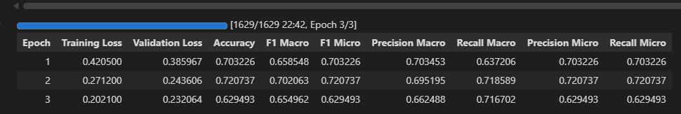
Figure 17: AfroXLMR model training results
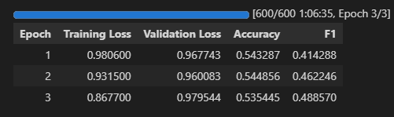
Figure 18: AfriBERTa model training results

6.3) How does ensemble learning of AfroXLMR and AfriBERTa influence sentiment classification performance?
In addition, reviewing a third study indicates that AfriBERTa, AfroLM and AfroXLMR provide less generalisation of African languages compared to models initially trained on African languages and after the conclusion of the study it has been indicate that AfriBERTa, AfroLM and AfroXLMR produced a greater result than the other models. However, the results indicate that there is not a specific model that resolves and suitable for different languages. The multilingual models performed well with AfriBERTa achieving a f1 score of 66%, precision of 66%, recall of 66% and accuracy of 66% while AfroXLMR achieving a f1 score of 67%, precision of 68%, recall of 67% and accuracy of 67%. The results draw the attention of the fact AfroXLMR performed like other models but still produced marginable better results (Aryal, Prioleau et al. 2023).
Therefore, ensemble learning of AfroXLMR and AfriBERTa positivly influence sentiment classification performance as stated above that three research paper indicate the models outperformed the other models used within the study and AfroXLMR performance was the best in all the studies with AfriBERTa closely behind. The positive impact the models display less generalisation and provide more precision. Achieving a f1 score between 64% and 71% compared to other models indicates that the two models are predicating at a high and better percentage compared to other models. In conclusion, ensemble learning of AfroXLMR and AfriBERTa positively influence sentiment classification performance.

7) Limitations
Even though the lexicon expansion process gave us a well-rounded dataset across the South African languages, there were still a few important limitations worth taking note of experienced during the whole process. One of the biggest challenges lied with using the Google Translate API, while it was overall more convenient and lightweight to run, it did have some setbacks like being not fully accurate or translating terms in a too literal way, especially with less common languages such as Sepedi and Shona. This caused in some cases that the original meaning of a word did not match up and/ or the positive/ negative sentiment of a word was not correctly identified. This problem also aligns with some other studies done, such as Agrawal, Fazili, and Jyothi (2024), where they found that translating tools often perform worse for smaller/ fewer known languages.
Another limitation came from the two-step translation process, meaning translating the French words to English first and then translating it to the other languages. This caused extra steps in translation which always pose the risk of losing value or changing core meaning of the original word. The main problem with miss-translations was due to the fact that some words meanings stems less from the word itself but rather the expressions behind it, thus translating using purely APIs did have some altercations in the intended meaning.
A further limitation was in the process of manually checking that was done by the group members themselves. Although there were team members who spoke the different languages, not all the languages that was present in the translations was spoken by the group members. Another limitation was the size of the dataset and the time it took to manually check the dataset for incorrectly translated words, which took up significant time leading to spot checking being utilised.
Other limitations experienced in this process was to do with the data cleaning choices. Some data cleaning methods to ensure that the models run as properly as possible included some frequency-based cleaning which in reality could have mistakenly removed unique words from the dataset due to it not featuring enough to build a model on. At the same time, some words lost meaning due to it relying on special characters and accents which also caused some risk in changing the meaning of a word slightly with multiple language translations.
Lastly, technical limitations we had to deal with was the processing power of devices, due to the training and using of models being directly linked to the processing power of the device it is running on, it was time consuming to be able to run individual checks on the dataset itself. This led to the limitation of what quality of checks we could do automatically such as translating words back into the original language to confirm their meaning.

7.1) Corpus-Based Enrichment
Corpus-Based enrichment relies heavily on its generation of PMI scores to determine sentiment bearing words. This means that to get the most accurate PMI score, we need access to a large corpora dataset to ensure every possible sentiment bearing sentence will be used to find a definitive sentiment for the target word. However, access to a large and diverse enough dataset is rare which makes it difficult to generate trustworthy PMI scores (Umar, Binji et al. 2024).
The integration of RAG to reassign polarity to yield new sentiments for targeted words is a crucial mediator to break the disparity between PMI scores and original polarity. While RAG has the ability to augment knowledge, it can also reinforce corpus biases and the factual accuracy of retrieved information depends in the quality of both the retrieval process and the external databases used (Umar, Binji et al. 2024).

8) Future Directions
The focus of future directions should be on the limitations in multilingual sentiment lexicon development for low-resource African languages. A solution could be by building a larger, more diverse text corpora, through the integration of multimodal data sources (e.g. social media, news, and transcribed speech) to mitigate the existing data scarcity (Chen et al., 2025). Furthermore, XAI techniques could be applied, in order to develop filtering strategies for domain-specific sentiment interpretation, that is transparent. Future studies should test a scalable lexicon-expansion framework that integrates corpus-based extraction, cross-lingual mapping and RAG, whilst benchmarking the performance of AfriBERTa and AfroXLMR, with the newly added African languages.

References
Abdalla, M. and G. Hirst (2017). "Cross-Lingual Sentiment Analysis Without (Good) Translation." ArXiv abs/1707.01626.
Aryal, S., H. Prioleau and S. Arya (2023). "Sentiment Analysis Across Multiple African Languages: A Current Benchmark."
Chen, L., S. Shang and Y. Wang (2025). "Bridging resource gaps in cross-lingual sentiment analysis: adaptive self-alignment with data augmentation and transfer learning." PeerJ Comput Sci 11: e2851.
Darwich, M., S. A. Mohd Noah, N. Omar and N. Osman (2019). "Corpus-Based Techniques for Sentiment Lexicon Generation: A Review." Journal of Digital Information Management 17: 296.
Dwivedi, R., D. Dave, H. Naik, S. Singhal, R. Omer, P. Patel, B. Qian, Z. Wen, T. Shah, G. Morgan and R. Ranjan (2023). "Explainable AI (XAI): Core Ideas, Techniques, and Solutions." ACM Computing Surveys 55(9): 1-33.
Gokani, M. (2023). "Exploring Sentiment Analysis in Low-resource Languages."
Klimczak, K. M., J. M. Fryczak, D. Hadro and J. Fijałkowska (2024). "Equivalent sentiment measures for cross-language analysis of corporate communications." MethodsX 12: 102745.
Lawless, L. J. R. and G. V. Civille (2013). "Developing Lexicons: A Review." Journal of Sensory Studies 28(4): 270-281.
Li, B., F. Luo, S. Haider, A. Agashe, T. Li, R. Liu, M. Miao, S. Ramakrishnan, Y. Yuan and C. Callison-Burch (2024). Multilingual Retrieval Augmented Generation for Culturally-Sensitive Tasks: A Benchmark for Cross-lingual Robustness. Annual Meeting of the Association for Computational Linguistics.
Mabokela, K., M. Primus and T. Celik (2025). "Advancing sentiment analysis for low-resourced african languages using pre-trained language models." PLoS One 20(6): e0325102.
Machlev, R., L. Heistrene, M. Perl, K. Y. Levy, J. Belikov, S. Mannor and Y. Levron (2022). "Explainable Artificial Intelligence (XAI) techniques for energy and power systems: Review, challenges and opportunities." Energy and AI 9.
Magueresse, A., V. Carles and E. Heetderks (2020). "Low-resource Languages: A Review of Past Work and Future Challenges."
Raychawdhary, N., S. Bhattacharya, C. Seals and G. V. Dozier (2025). "Empowering Sentiment Analysis in African Low-Resource Languages Through Transformer Models and Strategic Language Selection." IEEE Access 13: 147859-147873.
Rice, D. R. and C. Zorn (2021). "Corpus-based dictionaries for sentiment analysis of specialized vocabularies." Political Science Research and Methods 9(1): 20-35.
Sadia, A., F. Khan and F. Bashir (2018). "An Overview of Lexicon-Based Approach For Sentiment Analysis ".
Umar, M., H. I. Binji and A. T. Balarabe (2024). "Corpus-based Approaches for Sentiment Analysis: A Review." Asian Journal of Research in Computer Science 17(7): 95–102.
Pykes, K. (2019). Fuzzy String Matching in Python Tutorial. [online] Datacamp.com. Available at: https://www.datacamp.com/tutorial/fuzzy-string-python Eswara Rao Majji (2025). “Evaluating Google Translate as an AI-Powered Translation Tool: Strengths, Limitations, and Implications for Multilingual Communication”. Journal of Information Systems Engineering and Management, 10(54s), pp.135–141. doi:https://doi.org/10.52783/jisem.v10i54s.11044. Agrawal, A.S., Fazili, B. and Jyothi, P. (2024). Translation Errors Significantly Impact Low-Resource Languages in Cross-Lingual Learning. arXiv (Cornell University). doi: https://doi.org/10.48550/arxiv.2402.02080.

